Support Vector Machine

# VC dimension

* Assume training T sample $x_{i},y_{i}$ i=1,…T drawn from probability P(x,y) (IID) { $x_{i}∈R^{n},y=\{-1,1\}$}
* Consider family of machines (classifiers) $f\left(x,α\right)$: X -> {-1,1}
* Expect test error (risk): $R\left(α\right)= \int_{x,y}{\frac{1}{2}|y-f\left(x,α\right)|dP(x,y)}$
  + Average error rate on all possible value (x,y) <~ cannot be computed in practice
  + Probability of misclassification
* Empirical risk: (on training data)

$R_{emp}=\frac{1}{2T}\sum_{i}^{T}{|y_{i}-f(x_{i},α)|}$

## Idea of VC:

* Generally using validation data to watching error rate. But we can use complexity of the classifier
* Complexity is high -> reduce error -> overfit
* We need to optimize between error rate and classifier complexity

## VC Dimension

* We have N points can be labelled {1,-1} => 2^N ways to labels
* H is set of machines (classifiers) $f\left(x,α\right)$. H **shatters** N of there **exists** a set of N so that for **all possible labellings,** there exists a consistent $f\left(x,α\right)∈H$ (no error)
* The maximum value N that H can shatters is called Vapnik Chervonenkis V(H) = N. With $ε between [0,1]$
$$P\left(R\left(α\right)<R_{emp}\left(α\right)-\sqrt{\frac{h\left(\log\left(\frac{2T}{h}\right)+1\right)-\log\left(\frac{ε}{4}\right) }{T}}\right)≥1-ε with T=number of training samples$$

* Expected error <= Estimated error + VC confidence (choose model with minimum upper bound)

# Support vector machine

## Mathematical things

### Distance from a hyperplane

* Hyperplane equation $w^{T}x+b=0$
* Distance to hyperplane:
  + Project x on over H: $x^{'}=x-λw$
  + x’ belongs to H => $λ=\frac{\left(w^{T}x+b\right)}{w^{T}w}$

$d\left(x,H\right)=\left|x-x^{'}\right|=λ\left|\left|w\right|\right|=$ $\frac{|\left(w^{T}x+b\right)|}{|\left|w\right||}$

### Boundary margin

* distance from class to boundary
$$d\left(C_{1},B\right)=\min_{x_{1}∈C_{1}}{\frac{|\left(w^{T}x_{1}+b\right)|}{|\left|w\right||}}$$

* margin $m=\min_{x_{1},x_{2}}{\frac{\left|\left(w^{T}x_{1}+b\right)\right|+|\left(w^{T}x_{2}+b\right)|}{|\left|w\right||}}$
* best boundary $m=max_{w,b}\min_{x_{1},x_{2}}{\frac{\left|\left(w^{T}x_{1}+b\right)\right|+|\left(w^{T}x_{2}+b\right)|}{|\left|w\right||}}=\max_{w,b}{\frac{2c}{\left|\left|w\right|\right|}}$

## Hard margin

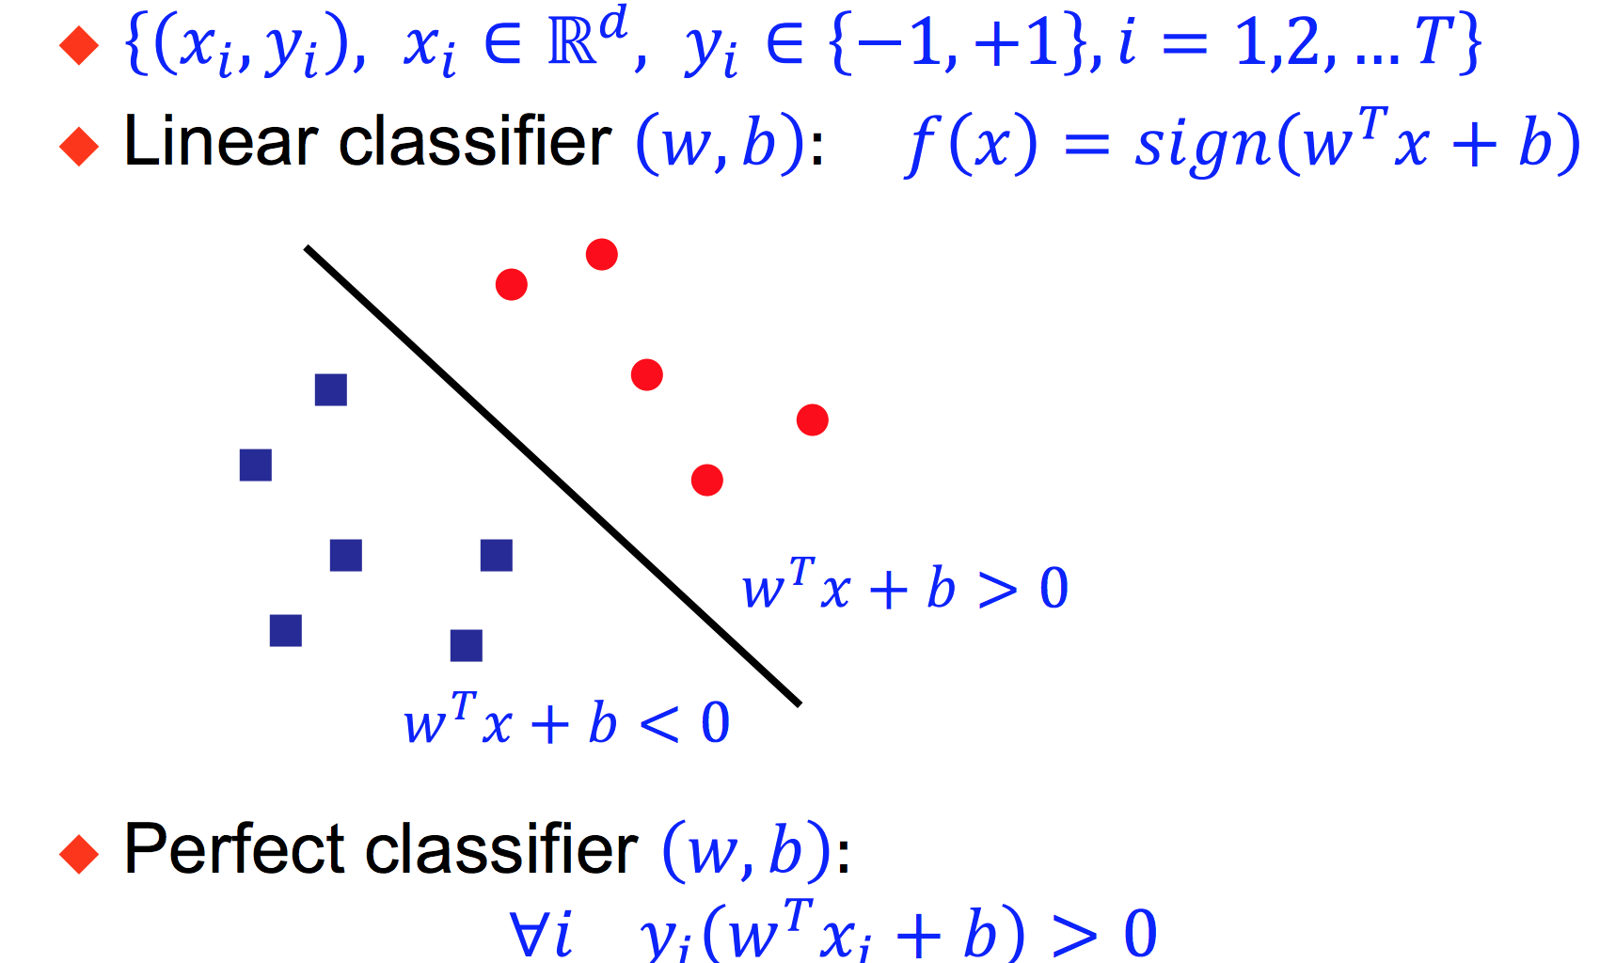

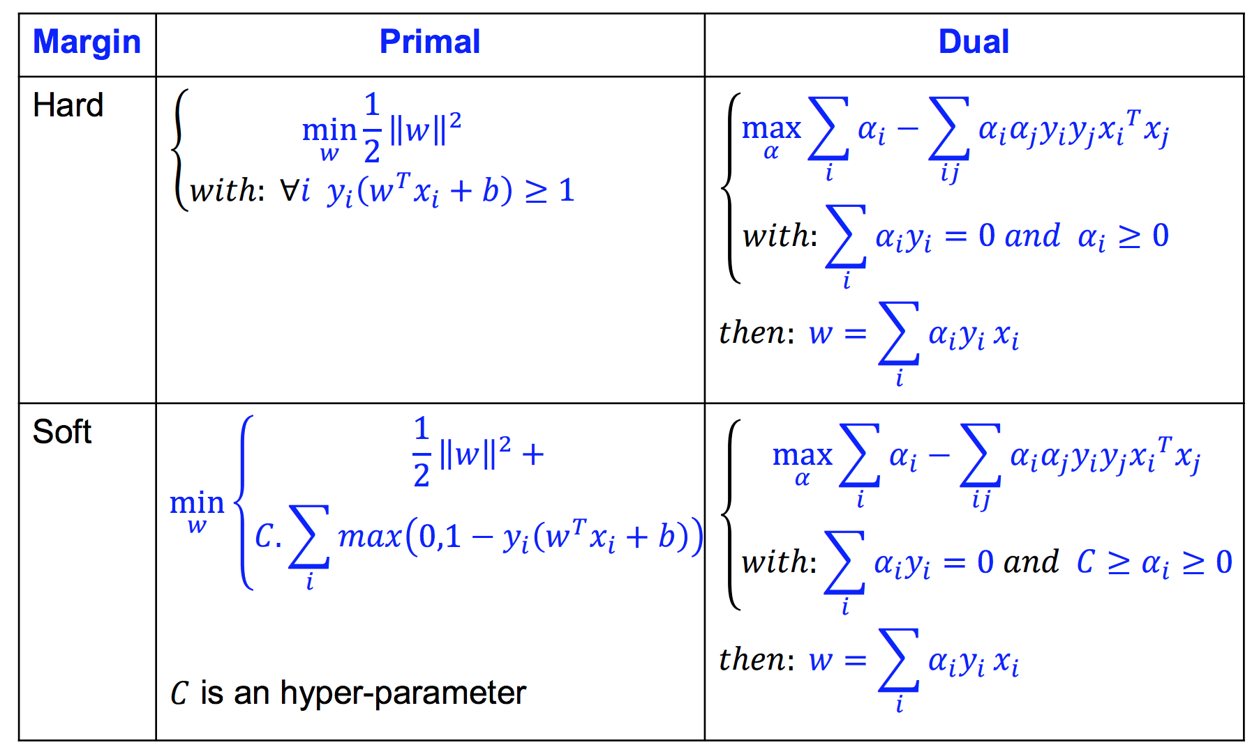

## Soft margin



$\min_{w}{\frac{1}{2}{\left|\left|w\right|\right|}^{2}+C*Number of error on training}$

$\min_{w}{\frac{1}{2}{\left|\left|w\right|\right|}^{2}+C \sum_{i}{\max\left(0,1-y_{i}\left(w_{i}^{T}+b\right)\right)}}$

## Non-linear boundary

* Move data into a higher dimension space and search for a linear separator
* Idea: transform input space into feature space $x→ϕ(x)$
* Because solving dual problem we only need scalar product $x_{i}^{T}x_{j}$
* Kernel $K\left(x_{i},x_{j}\right)= ϕ{\left(x_{i}\right)}^{T}ϕ(x_{j})$ similarity measure between x_i and x_j
* Mercer’s theorem: every possitive semi definite symmetric function
* The dual problem:
$$\left\{\begin{aligned}\max_{α}{\sum_{i}{a_{i}-\frac{1}{2}\sum_{i,j}{a_{i}a_{j}y_{i}y_{j}K(x_{i},x_{j})}}} \\ with \sum_{i}{a_{i}y_{i}=0, C≥a≥0}\end{aligned}\right.$$

* Weight vector is $w=\sum_{i}{α_{i}y_{i}ϕ\left(x_{i}\right)}$
* Discriminant function $f\left(x\right)=\sum_{i}{a_{i}y_{i}K\left(x_{i},x\right)+b}$

### Kernel sample

* D-th degree polynomial $K\left(x,x'\right)={\left(1+x^{T}x\right)}^{d}$, input space n => feature space combination(d,n+d)
* Radial basis $K\left(x,x'\right)=e^{-\frac{1}{2σ^{2}}{\left|\left|x-x^{'}\right|\right|}^{2} }$
* Sigmoid with parameter alpha and beta $K\left(x,x'\right)=tanh⁡(αx^{t}x^{'}+β)$